Mehmet Izol

Doctor Tai Cleveland

COMP 3324

Week 7 – Lab – Linux Command Injection

4/7/2023

Linux Command Injection

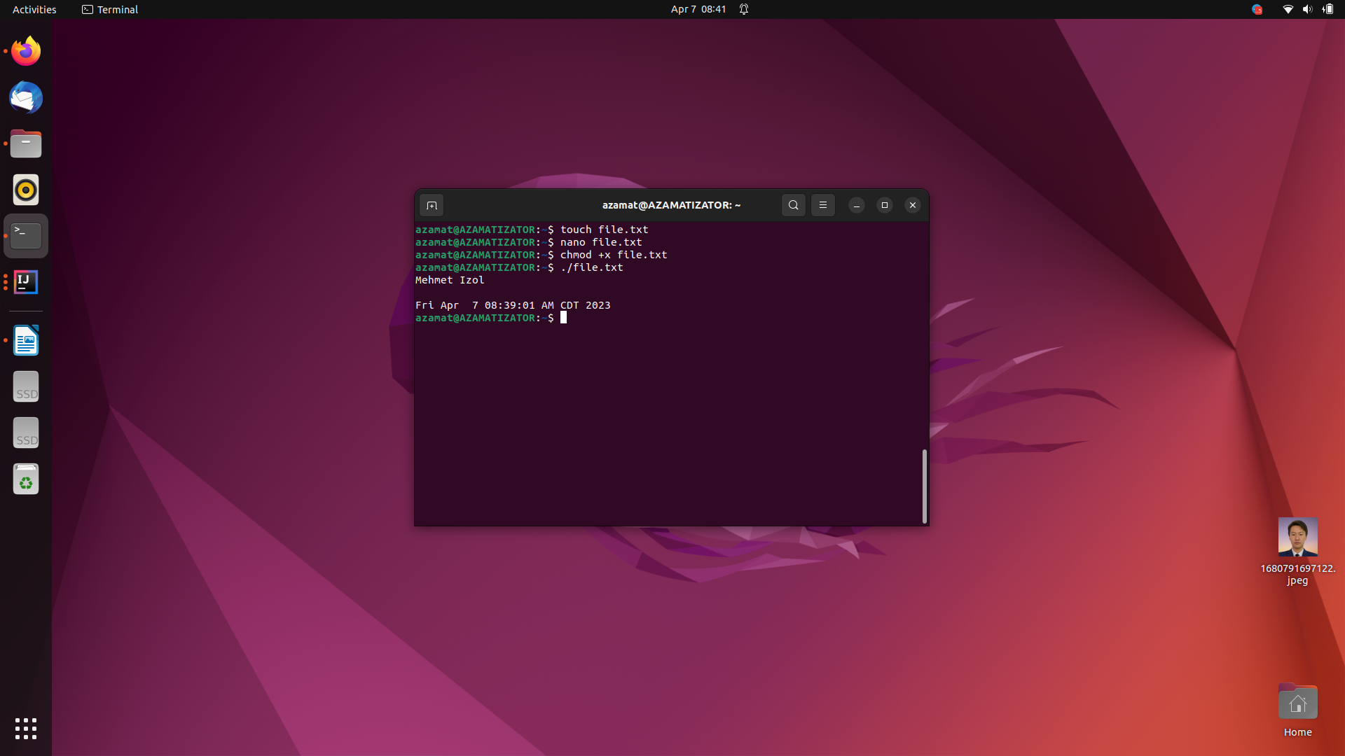

# I used Ubuntu Linux

* I learned lots of commands both for linux bash and python automation
* I also know how to create/detele files/directories, git, settings
* I used the laptop of Azamat Salamatov, my friend